**Description of Screenshots:**

Screenshot 2021-02-05 (#1) – Creating the 2 nodes and the network:

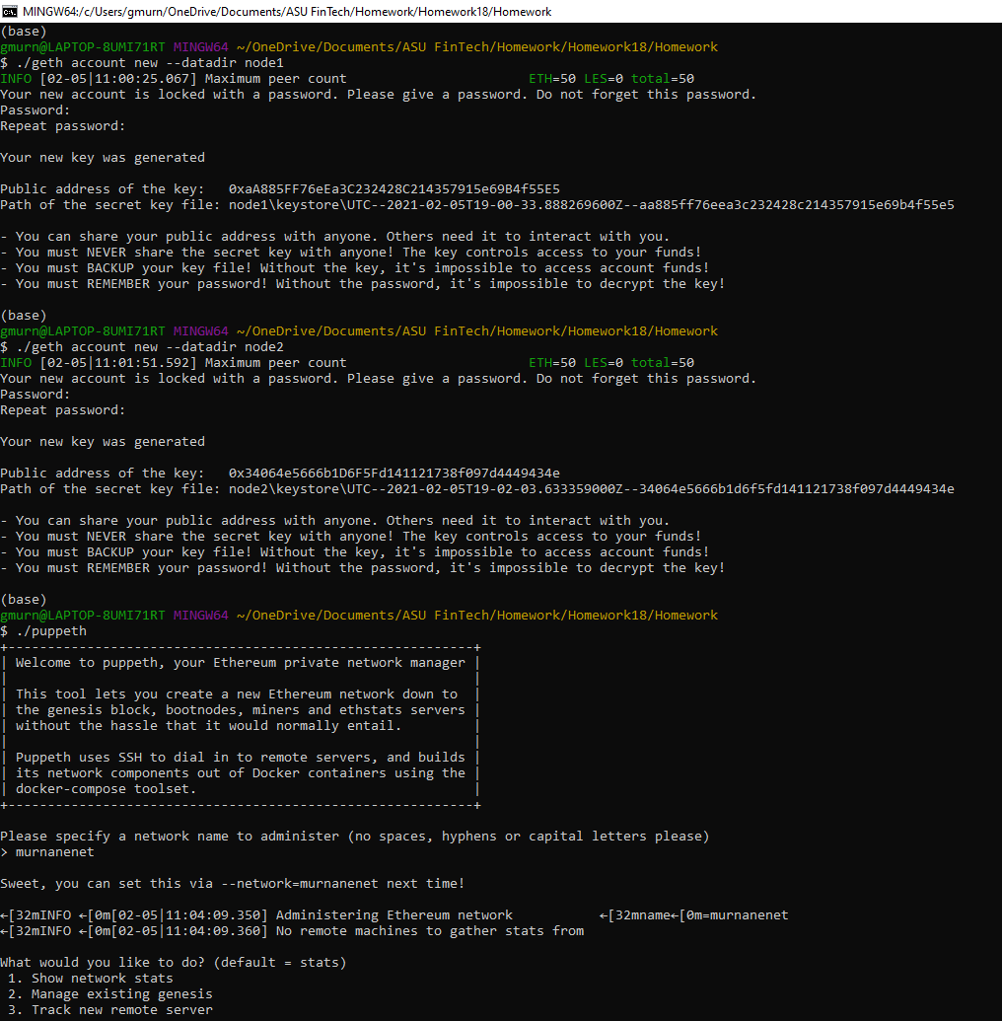

![custom-nodes](Screenshots/Screenshot 2021-02-05 (#1).png)

Screenshot 2021-02-05 (#2) – Create the new network and Genesis block

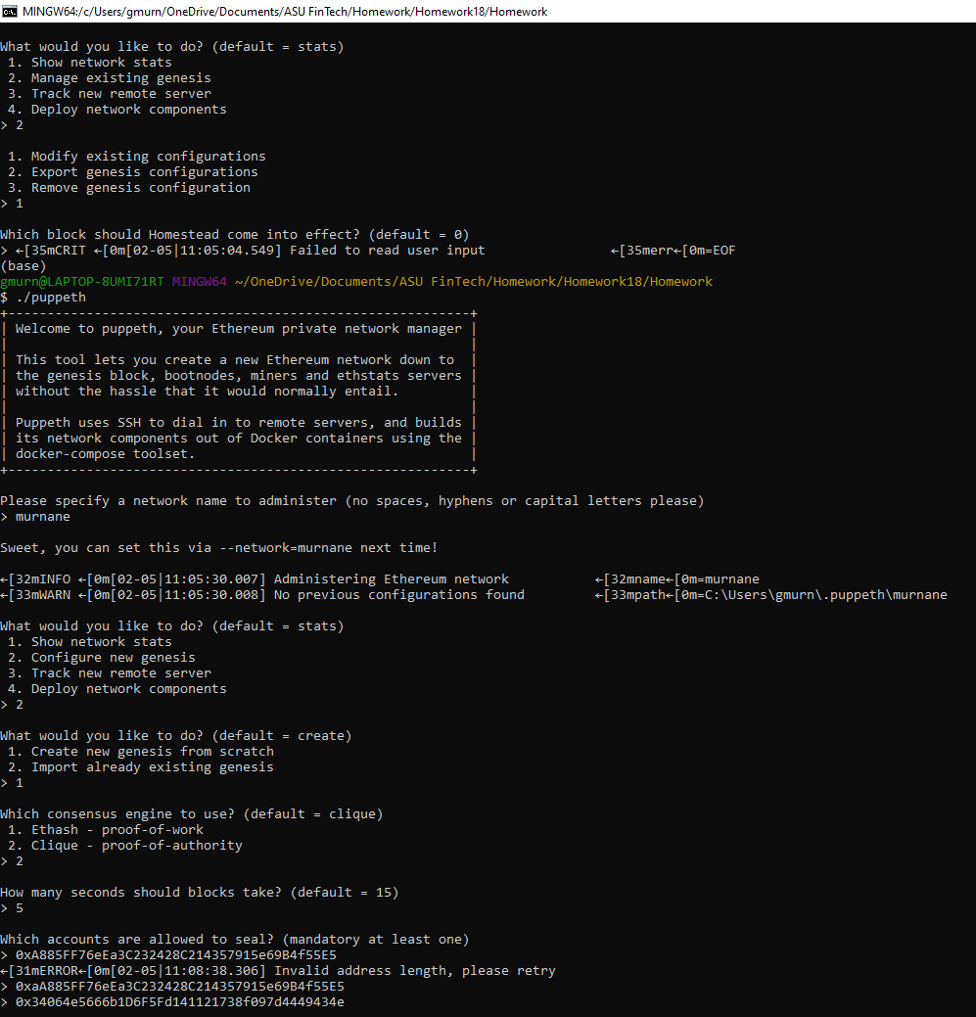

![new_network](Screenshots/Screenshot 2021-02-05 (#2).png)

Screenshot 2021-02-05 (#3) – Export the Genesis configurations

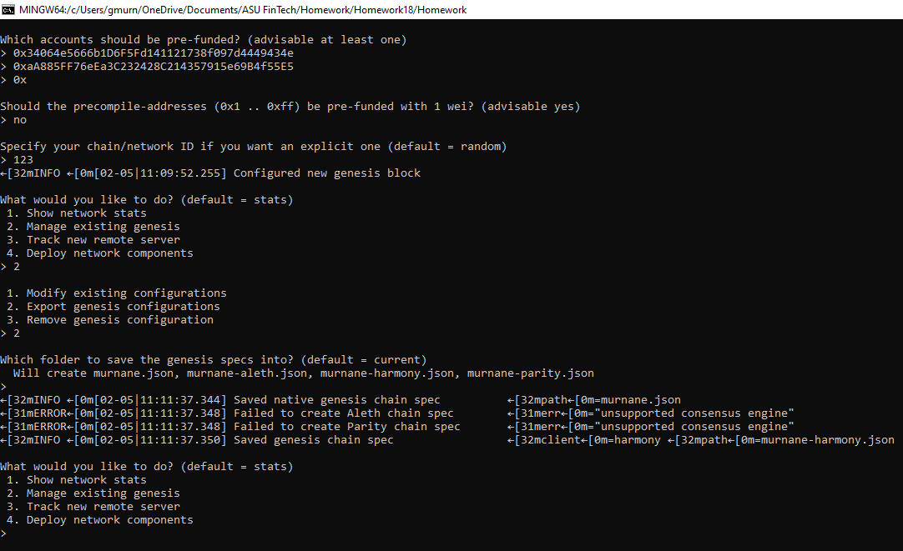

![Genisis](Screenshots/Screenshot 2021-02-05 (#3).png)

Screenshot 2021-02-05 (#4) – Initializing the 2 nodes

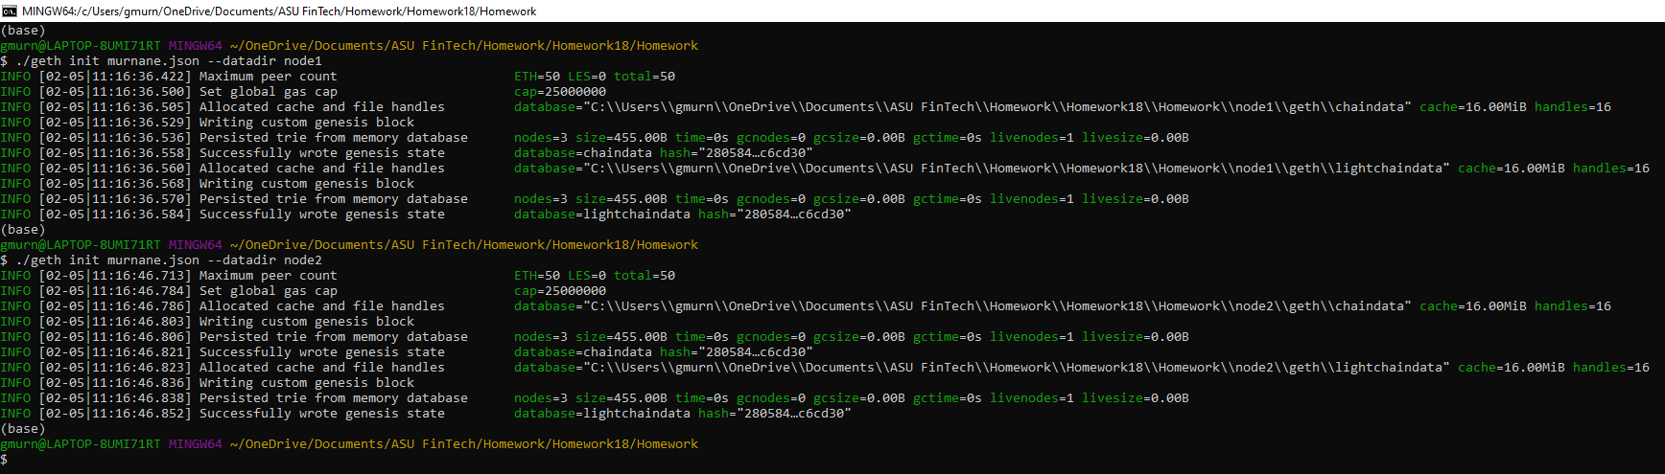

![initializing-nodes](Screenshots/Screenshot 2021-02-05 (#4).png)

Screenshot 2021-02-04 (#4) – Mining:

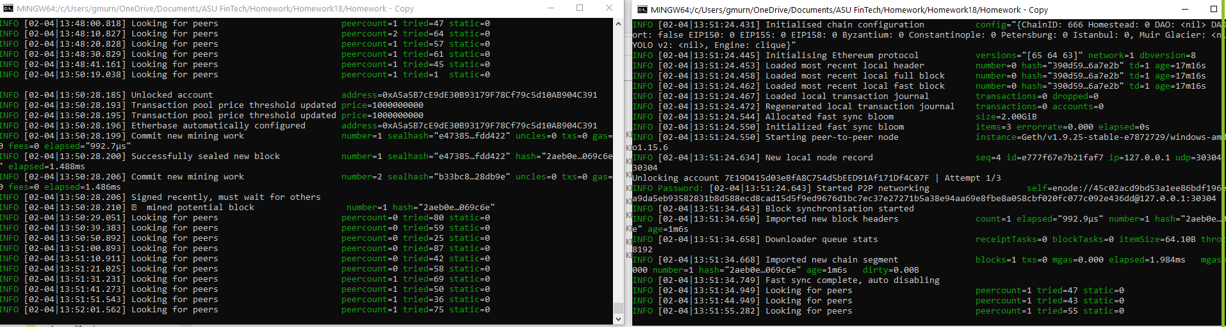

![mining](Screenshots/Screenshot 2021-02-04 (#4).png)

Screenshot 2021-02-05 (#5) – Setting up your custom node

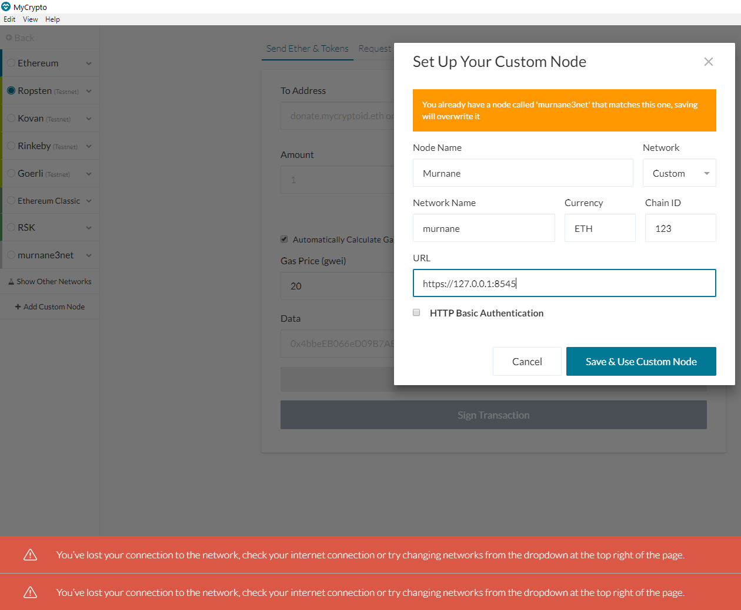

![MyCrypto](Screenshots/Screenshot 2021-02-05 (#5).png)